**Part 2: Routh Criterion**

A-Problem Statement:

For a given characteristic equation, Use Routh criteria to state if the system is stable or not and if the system is not stable, list the number and values of poles in the RHS of the s-plane.

B-Main Features:

-The program takes the degree of the characteristic equation ( n ) and the coefficient of each variable in the equation from ( S0 to Sn )andthen uses the Routh-Hurwitz Stability Criterion to check the stability of the system by checking the number of sign changes in the first column in routh table.

-prints the routh table.

-tells the user if the system is stable or not.

-if the system is unstable, it provides the place of the roots in the RHS of S-Plane which causes the unstability.

-it handles the special case of having an entry in the first column of the routh table with zero value by replacing the zero with a very small value ( EPSILON = 10-9) and continues the calculations.

-it handles the special case of having a row full of zeros in the routh table by replacing that row by the derivative of the auxiliary equation and check if there are duplicate roots on the jw-axis that will lead to the system being unstable.

C-Data Structures:

One-dimensional arrays and two-dimensional arrays are used to represent routhTable, coefficient Array, and other parts of code.

D-Main modules:

The program consists of a single module and multiple methods, each on for a particular purpose (some methods are further illustrated and other assumed to be clear from the names of the methods):

* checkZeroRow
* replaceZeroRow => used to replace the zero row with the derivative of the auxiliary equation
* printRouthTable => used to print at any point of code and stops printing if a zero row is encountered
* checkStability => decides if the system is stable or not based on the number of sign changes in the first column of routh table or if there are duplicate roots in the RHS of S-Plane
* createRouthTable => calculate entries in the routh table
* getAuxiliaryCoefficients => get coefficients of the auxiliary array
* checkDuplicateRoots => check the existence of multiple roots on the jw-axis
* findRootsInRHS
* main => takes input from the user regarding the degree of characteristic equation and its coefficients and calls other methods to perform the required functionality

D-Algorithms used:

Routh-Hurwitz Stability Criterion.

E-Sample Runs:

Test 1:

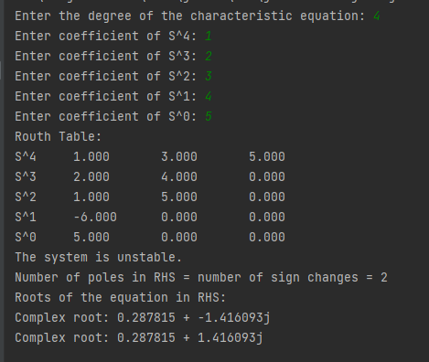

Test 2:

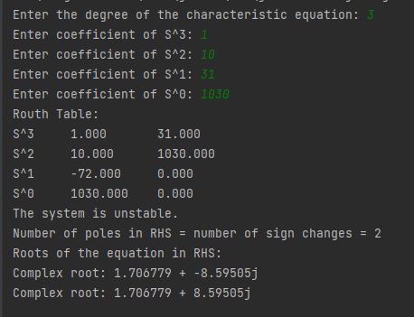

Test 3:

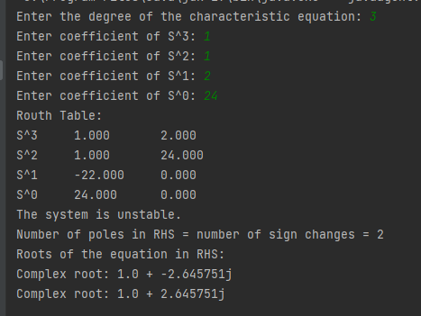

Test 4:

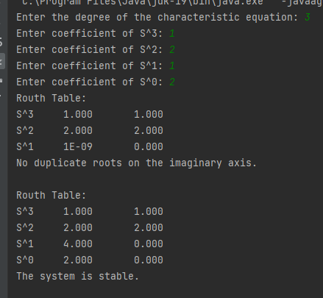

Test 5:

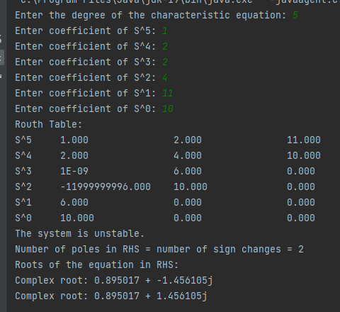

Test 6:

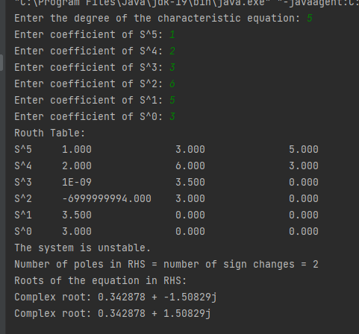

Test 7:

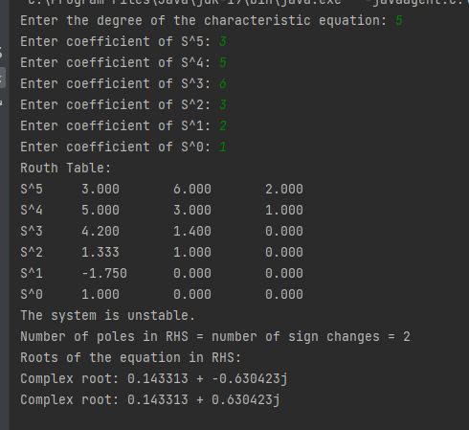

Test 8:

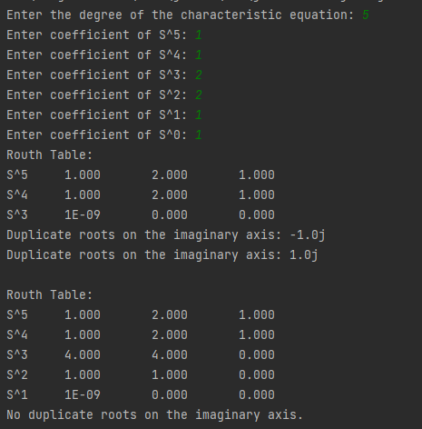

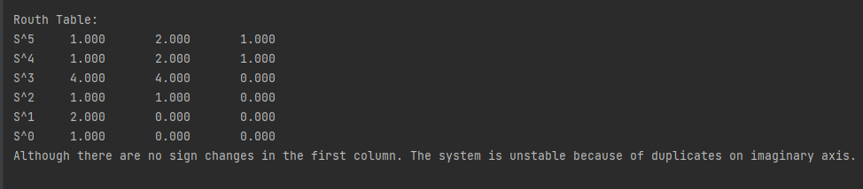

Test 9:

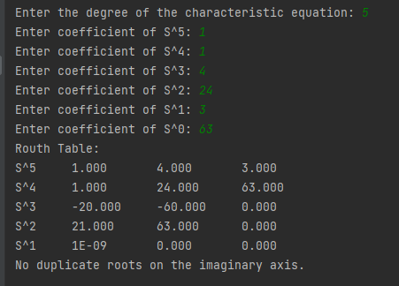

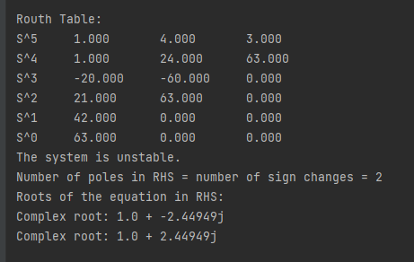

F-User Guide:

The user starts by entering the degree of the equation that he wants to test its stability, then enters the coefficients of the variables in the equation one after the other starting from the coefficient of the highest degree variable ( Sn ) to the coefficient of the lowest degree variable (S0).